Date: 13.12.2024
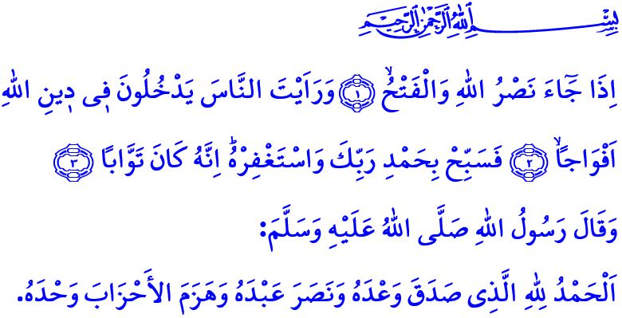WITH HARDSHIP COMES EASE
Dear Muslims!
We are witnessing the days when the Messenger of Allah (saw) and his esteemed companions began their preparations for the historic conquest of Mecca. Let us remember the conquest of Mecca, rich with signs and profound wisdom, in this Friday’s khutbah. Let us take a moment to reflect once again on the events of that day. Let us draw the essential lessons that can bring positive contributions to our lives.
Dear Believers!
It was the eighth year after the Hijrah. Our Prophet (saw) and his Companions embarked on a journey to Mecca to reclaim their homeland, which they had left with heavy hearts, and to purify the Ka‘bah from idols. After completing the preparations for the conquest, the Islamic army entered Mecca. Our beloved Prophet (saw), with great humility, praised his Lord (swt), turned towards the Ka‘bah, performed tawaf around the Bayt al-Allah, and performed two rak’ahs of salah. Then, he ascended the steps of the Ka‘bah and said, “Praise be to Allah, Who fulfilled His promise of the conquest of Mecca, aided His servant, and defeated the enemy forces alone.” The people of Mecca gathered around the Ka‘bah, anxiously and fearfully awaiting the decision of the Messenger of Allah (saw) regarding their fate. The Messenger of Mercy (saw) addressed the gathered crowd with compassion and kindness: “Just like Prophet Yusuf, I am telling you, لَا تَثْر۪يبَ عَلَيْكُمُ الْيَوْمَۜ يَغْفِرُ اللّٰهُ لَكُمْۘ وَهُوَ اَرْحَمُ الرَّاحِم۪ينَ ‘There is no blame on you today. May Allah forgive you! He is the Most Merciful of the merciful!’ You are all free to go.”
Dear Muslims!
The conquest of Mecca teaches us that after every difficulty comes ease, after every hardship comes relief, and after every sorrow comes joy. In this regard, our Lord Almighty (swt) states in the Surah al-Sharh, اِنَّ مَعَ الْعُسْرِ يُسْراًۜ .فَاِنَّ مَعَ الْعُسْرِ يُسْراًۙ “So, surely with hardship comes ease. Surely with ˹that˺ hardship comes ˹more˺ ease.” The conquest of Mecca foretells that truth will undoubtedly prevail over falsehood, justice over oppression, and good over evil. It teaches us the importance and necessity of conquering hearts before conquering lands. It reminds us not to despair of Allah’s (swt) help in times of loss, and to uphold justice, mercy, and fairness as guiding principles in times of victory.
Esteemed Believers!
History shows us that oppression has never prevailed, nor will it ever prevail. Throughout history, oppressors have never succeeded in achieving their treacherous ambitions, and they never will. Our Lord Almighty’s (swt) promise, وَاللّٰهُ مُتِمُّ نُورِه۪ وَلَوْ كَرِهَ الْكَافِرُونَ “Allah will ˹certainly˺ perfect His light, even to the dismay of the disbelievers.”, will absolutely come true. Those who seek to prevail through oppression have met a dreadful end, and will continue to meet such an end. Those who aid oppression and support the oppressors will never escape the wrath of Allah, just like the oppressors themselves. The cries of the oppressed have never gone unheard, nor will they ever. Our Prophet’s (saw) warning in this regard is quite clear: اِتَّقِ دَعْوَةَ الْمَظْلُومِ، فَإِنَّهُ لَيْسَ بَيْنَهُ وَبَيْنَ اللّٰهِ حِجَابٌ “Beware of the supplication of the oppressed; for indeed there is no barrier between it and Allah.”
Dear Muslims!
Let us continue to stand by the oppressed, wherever they may be in the world, regardless of their religion, race, or color. Let us unite under the guidance of the Qur’an and Sunnah, just as we did during the conquest of Mecca. Let us keep our hopes for the future alive by upholding the law and ethics of brotherhood. Let us remain vigilant against those who seek to sow seeds of division and discord among us.
Dear Believers!
Endless praise and gratitude be to Allah the Almighty (swt), Who, as He granted our ancestors the honor of providing protection and support to the oppressed from Andalusia to the Balkans, from Crimea to the Caucasus, and from Asia to Africa, has also bestowed upon us, their descendants, the privilege of adopting the same path and earning the prayers of the oppressed. I ask our Almighty Lord (swt) to grant success to our brothers and sisters who are striving for truth and justice against the oppressors, working for the good to prevail on earth, and endeavoring for all people to live in dignity, safety, and freedom.
I would like to conclude this Friday’s khutbah with the meaning of the Surah al-Nasr: “When Allah’s ˹ultimate˺ help comes and the victory ˹over Mecca is achieved˺, and you ˹O Prophet˺ see the people embracing Allah’s Way in crowds, then glorify the praises of your Lord and seek His forgiveness, for certainly He is ever Accepting of Repentance.”

Ibn Majah, Diyat, 5.
Yusuf, 12/92; Waqidi, Maghazi, II, 835; Bayhaqi, al-Sunan al-kubra, IX, 195.
Sharh, 94/5,6.
Saf, 61/8.
Bukhari, Zakat, 63.
Nasr, 110/1-3. General Directorate of Religious Services

